ERD IN CLASS EXAMPLES

Business rules (i.e., relationships)

Example 1

- a professor teaches zero, one or many classes and a class is taught by one professor
- a course may generate zero, one or many classes and a class comes from one course
- a class is held in one room but a room has many classes

Example 2 (try this at home and if you have questions raise them next class)
- an invoice is written by one salesrep but a salesrep writes many invoices
- a vendor sells many products but a product is bought from one vendor
- an invoice has one or many products and a product is found on zero, one or many invoices

Example-1 Solution (Incomplete)

The many-to-many relationship is not resolved, therefore the solution is incomplete. In the final solution the many-to-many must always be resolved.

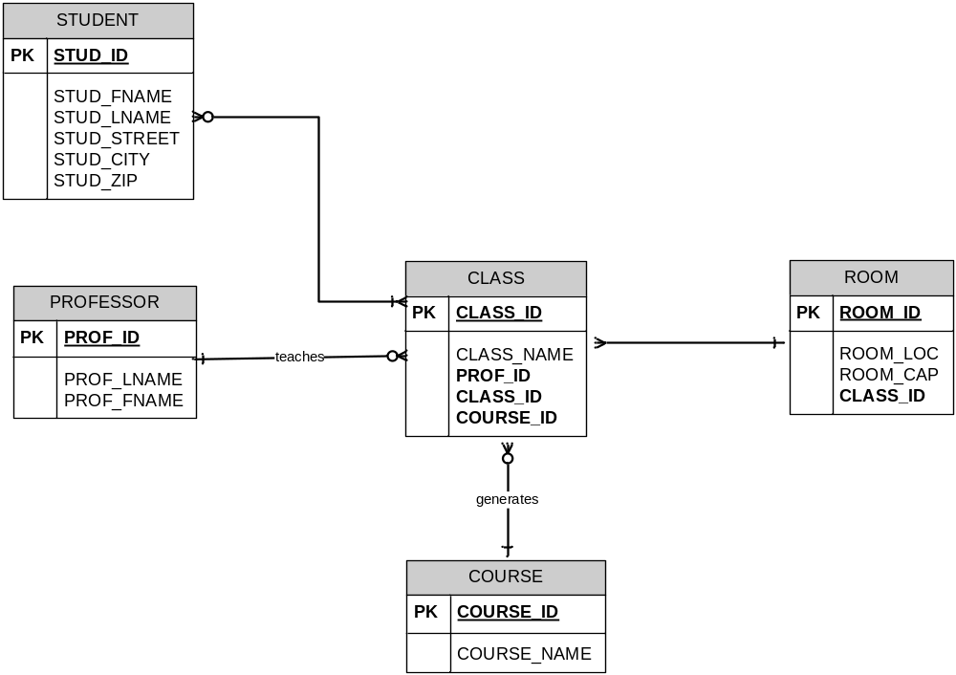

Final Solution (Complete)

In this example, the many-to-many relationship between student and class is resolved.

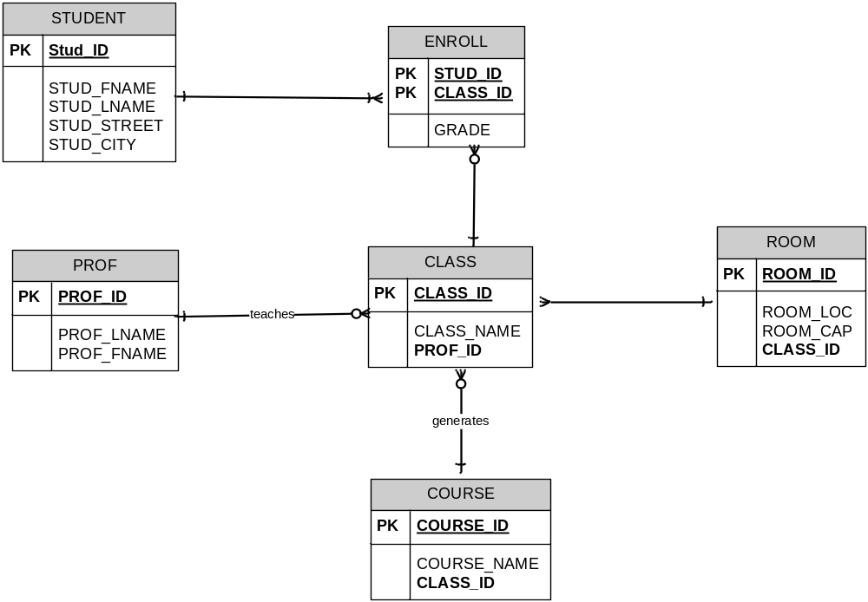

Solution to the INVOICE problem

